Poseur of the Year 2016.

To Present this award to a worthy man

I think you all can see

We must consider many things in order to agree

So lets start off with a thank you gift

And so we all know more

For a reference wrote, thins kindly gift was sent

Unfortunately to the wrong door

We could consider collecting Nessie, from a boatyard far away

Turning up without a call to find the yard was closed that day

Weight belts lost, brake shoes killed to name but just a few

Drinking beer from a mixing bowl all these things are true

Considering all this, and probably more without further Ado

I’m sure you will all help congratulate and no one will be sad

When I tell you all that Poseur of the Year

Is our one and only Brad.

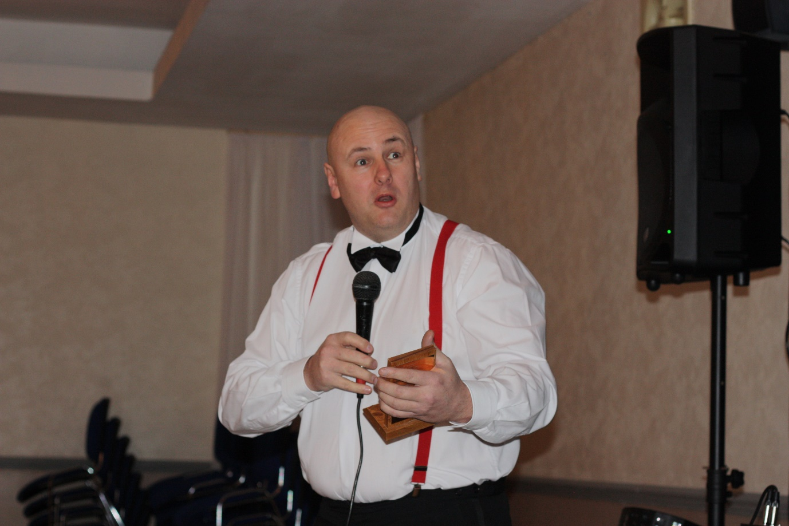

Brad Markham.

TSAC Poseur of the Year 2016.