
Poseur of the Year 2015.

A New year
A new year of diving
A year of drinking, milling & Fab
Friendly Banter
And more drinking as is the TSAC way
Above all plenty of opportunities to win the "prize"
It is known for members to lose a fin , a mask
Fall off a RIB , jump in with an undone drysuit zip
or even turn up at the wrong dive site
But hey on this occasion it goes to someone
who quite literally has frozen eye lids
after last year's party
This individual shouldn't have told me that story

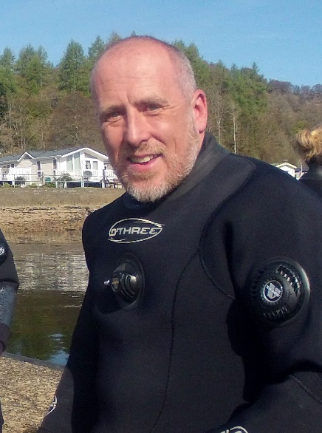
This year’s poseur, is you, Nick Haigh

