Poseur of the Year 2015.

A New year

A new year of diving

A year of drinking, milling & Fab

Friendly Banter

And more drinking as is the TSAC way

Above all plenty of opportunities to win the "prize"

It is known for members to  lose a fin , a mask

Fall off a RIB , jump in with an undone drysuit zip

or even turn up at the wrong dive site

But hey on this occasion it goes to someone

who quite literally has frozen eye lids

after last year's party

This individual shouldn't have told me that story

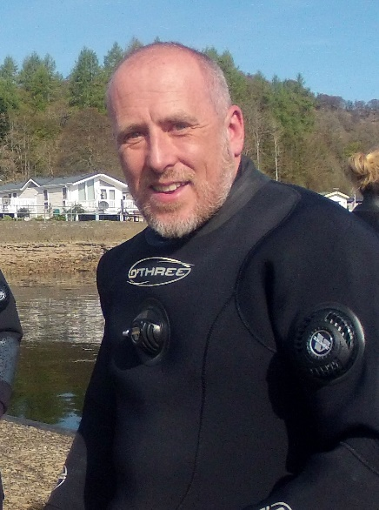This year’s poseur, is you, Nick Haigh